Newcastle and Lake Macquarie Art Society
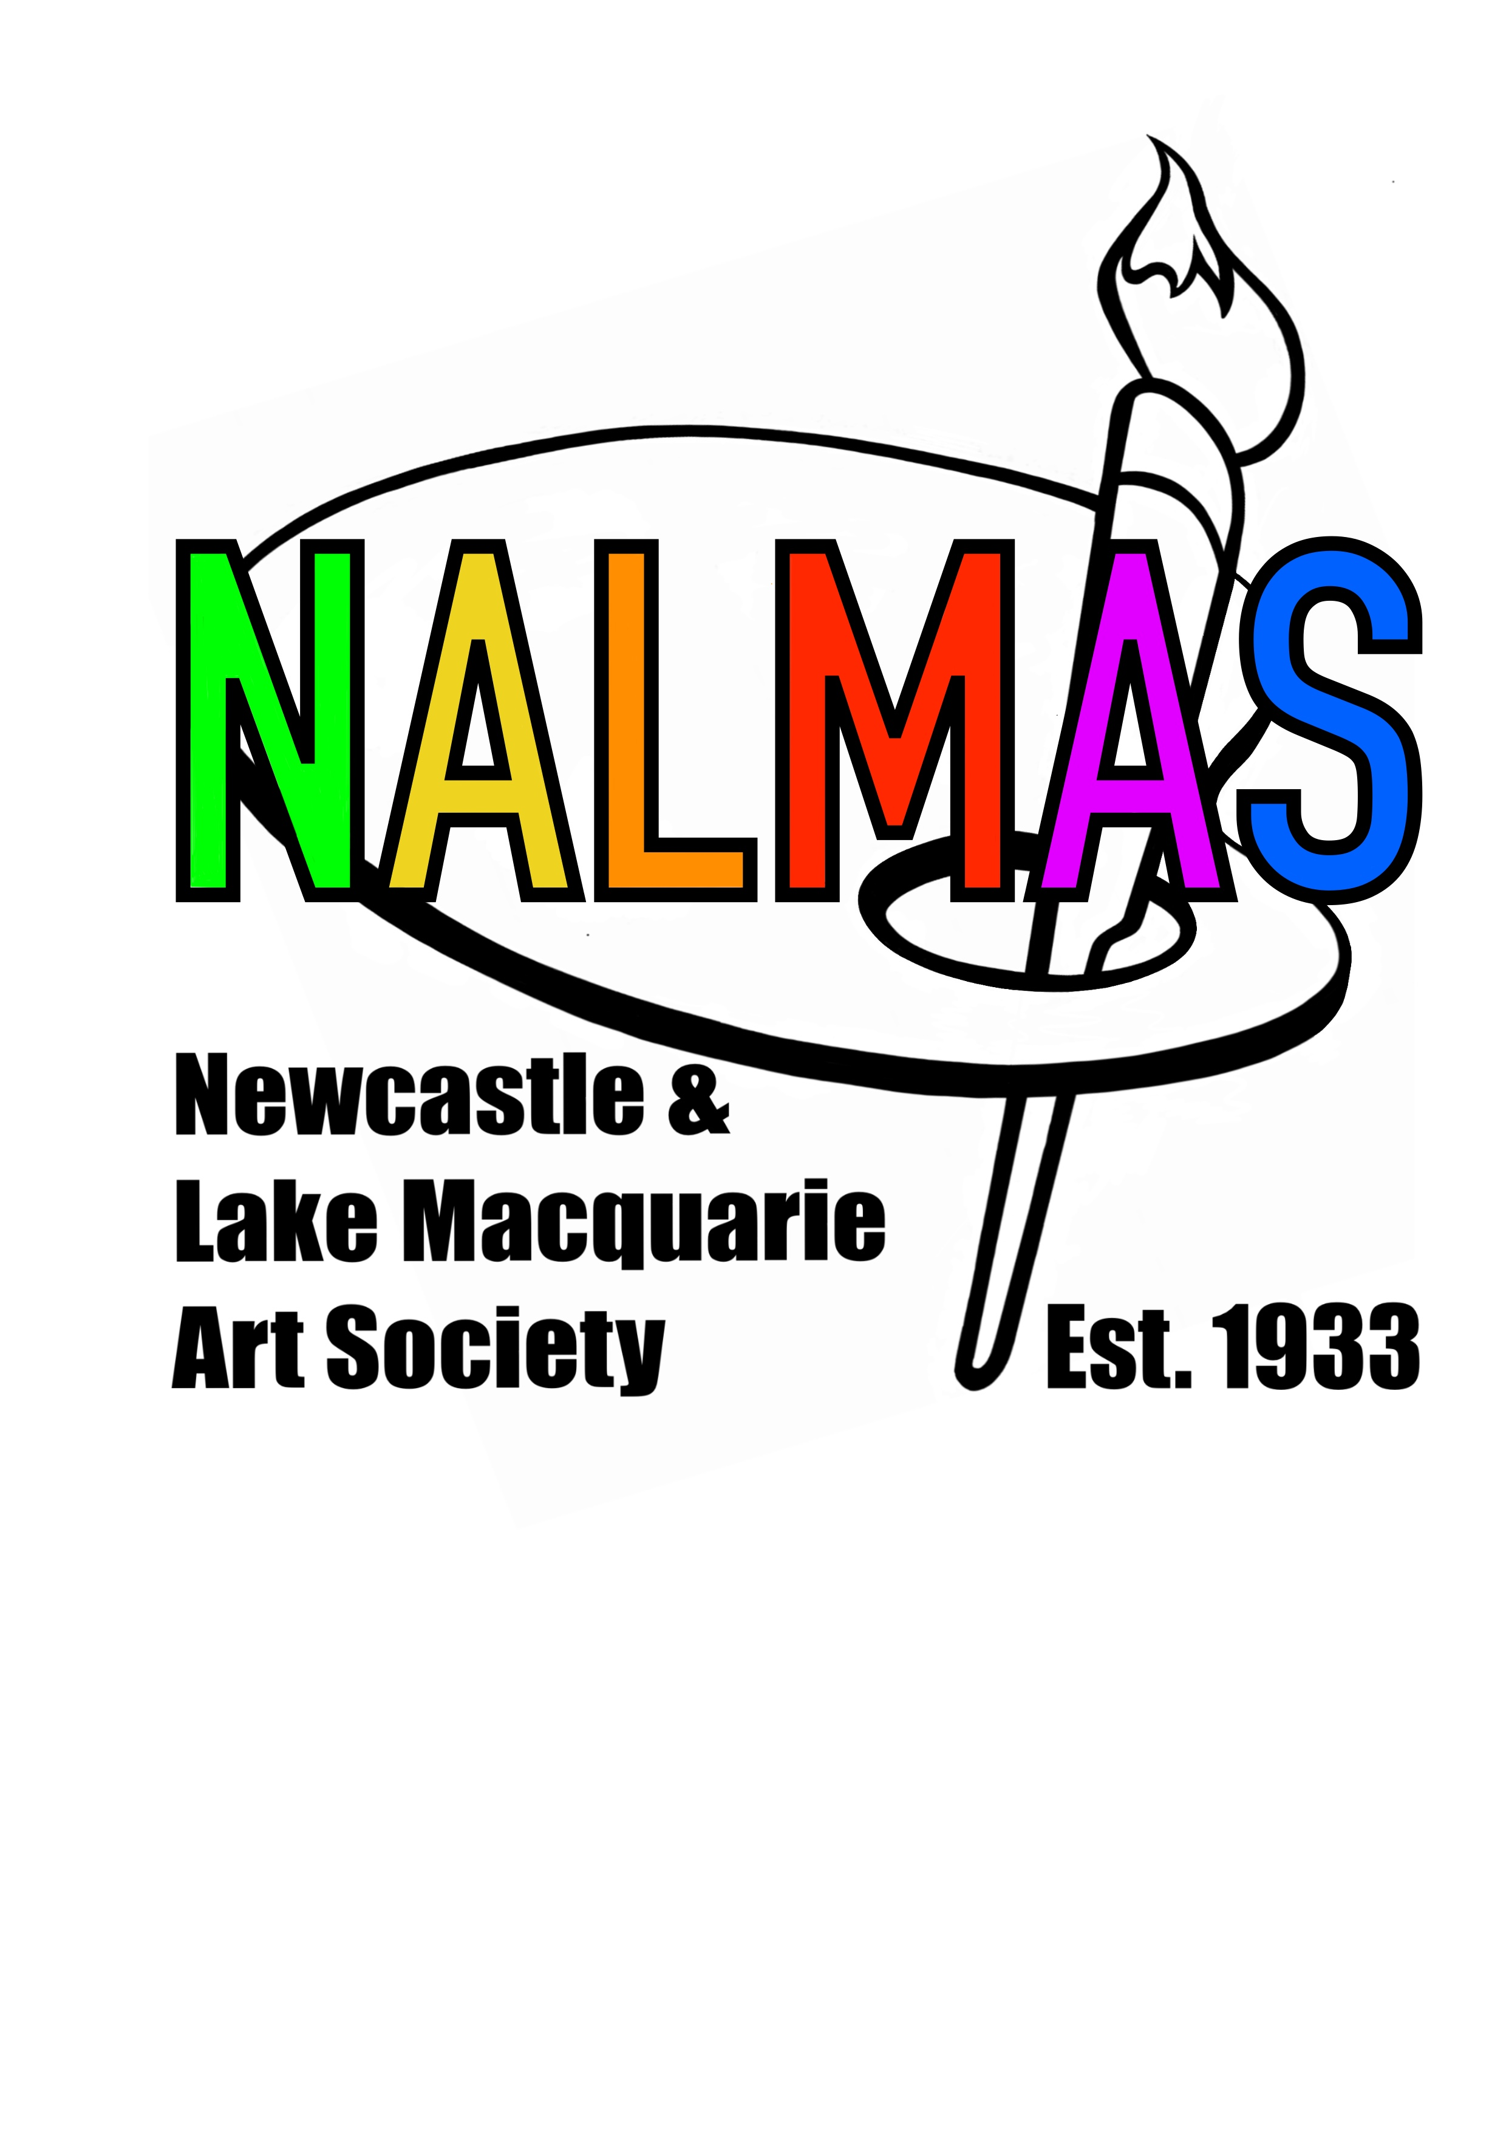
Lola Rose Award Exhibition
Rathmines Theatre Boiler Room
June 21st to 27th 2021
25 Stilling Street Rathmines
Proudly part of the Lake Macquarie Council month long Dobell Festival of Art June 2021
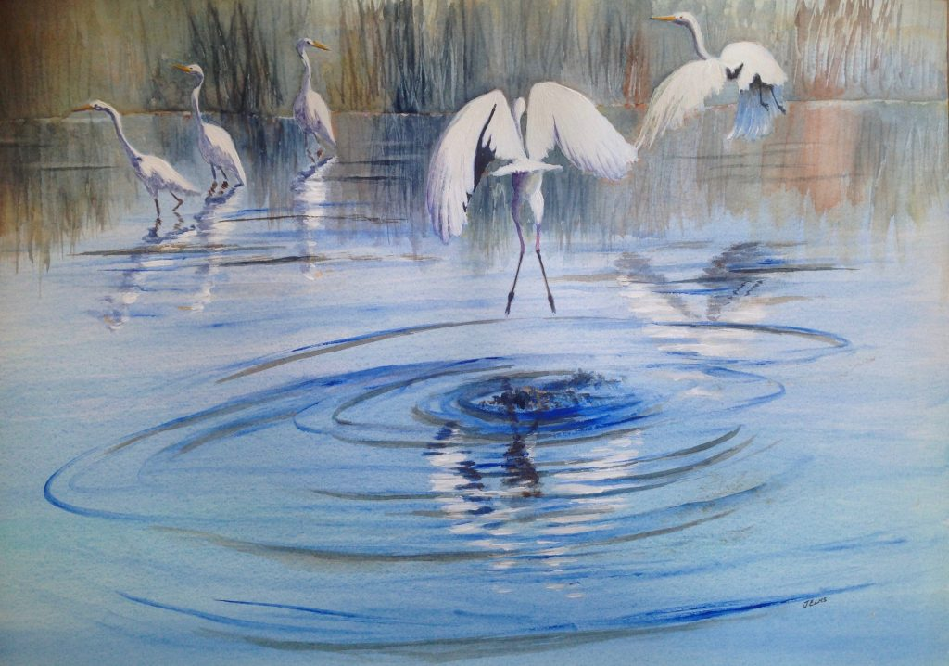

“Egrets in Flight” by Jenny Eks, winner of the Ellen Kilpatrick Award
All welcome to come along and join in with this week long festival of art. There will be something for everyone to enjoy including:
- Art exhibition and sale of art by members of the Newcastle and Lake Macquarie Art Society Inc. This exhibition will be held in the heritage listed Boiler Room at the Rathmines Theatre.
- An exhibition of art by students of local schools in the main theatre from Thursday the 24th of June to Sunday the 27th of June.
- Demonstrations, displays and sale of art from individual members of the Newcastle and Lake Macquarie Art Society Inc.
- Classes conducted by members of the society for all skill levels. All classes are only $25 per class. Come along and try a new painting style or technique. Beginners are welcome.
Request a brochure or check out our website, www.newcastleartsociety.com.au for all details on times and material requirements. For bookings please
call Kate on 0400 494 490.
Newcastle and Lake Macquarie Art Society
Lola Rose Award Exhibition
Rathmines Theatre Boiler Room
June 21st to 27th 2021
25 Stilling Street Rathmines
Proudly part of the Lake Macquarie Council month long Dobell Festival of Art June 2021

“Egrets in Flight” by Jenny Eks, winner of the Ellen Kilpatrick Award
All welcome to come along and join in with this week long festival of art. There will be something for everyone to enjoy including:
- Art exhibition and sale of art by members of the Newcastle and Lake Macquarie Art Society Inc. This exhibition will be held in the heritage listed Boiler Room at the Rathmines Theatre.
- An exhibition of art by students of local schools in the main theatre from Thursday the 24th of June to Sunday the 27th of June.
- Demonstrations, displays and sale of art from individual members of the Newcastle and Lake Macquarie Art Society Inc.
- Classes conducted by members of the society for all skill levels. All classes are only $25 per class. Come along and try a new painting style or technique. Beginners are welcome.
Request a brochure or check out our website, www.newcastleartsociety.com.au for all details on times and material requirements. For bookings please
call Kate on 0400 494 490.
Newcastle and Lake Macquarie Art Society
Lola Rose Award Exhibition
Rathmines Theatre Boiler Room
June 21st to 27th 2021
25 Stilling Street Rathmines
Proudly part of the Lake Macquarie Council month long Dobell Festival of Art June 2021

“Egrets in Flight” by Jenny Eks, winner of the Ellen Kilpatrick Award
All welcome to come along and join in with this week long festival of art. There will be something for everyone to enjoy including:
- Art exhibition and sale of art by members of the Newcastle and Lake Macquarie Art Society Inc. This exhibition will be held in the heritage listed Boiler Room at the Rathmines Theatre.
- An exhibition of art by students of local schools in the main theatre from Thursday the 24th of June to Sunday the 27th of June.
- Demonstrations, displays and sale of art from individual members of the Newcastle and Lake Macquarie Art Society Inc.
- Classes conducted by members of the society for all skill levels. All classes are only $25 per class. Come along and try a new painting style or technique. Beginners are welcome.
Request a brochure or check out our website, www.newcastleartsociety.com.au for all details on times and material requirements. For bookings please
call Kate on 0400 494 490.

